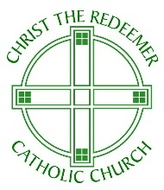

Christ The Redeemer Catholic Church
Lake Orion, Michigan
Christ The Redeemer Catholic Church is seeking a faith-filled, part-time Lead Catechist for Atrium 3 to join our Catechesis of the Good Shepherd program this fall.
Our parish is blessed to offer all three atria levels, and Atrium 3 serves our 5th, 6th & 7th graders as they deepen their relationship with The Good Shepherd and prepare for their journey for Confirmation.
About the Role:
- Lead weekly Atrium 3 sessions during the school year (September-May).
- Prepare the environment and materials.
- Mentor and support assistant catechists.
- Collaborate with the Coordinator of Faith Formation.
- Assist and support Sacramental Preparation Events for First Eucharist and Reconciliation.
- Hours: Part-time, approx. 8-10 hours p/week.
- Compensation: Commensurate with experience.
Qualifications:
- Practicing catholic.
- CGS Level 1, 2 and/or 3 formation completed or willingness to complete.
- Strong organizational and communicational skills.

To Apply:
- Please submit a resume and brief cover letter to Suzy Rhadigan at formationcoordinator@ctredeemer.org
- You can also visit our website at https://www.ctredeemer.org/

Atrium 3 – Prayer Table Area

